Atm management

**Code**

**#!/usr/bin/python**

**import string**

**import os**

**# creating a list of users, their PINs and bank statements**

**users = ['user1', 'user2', 'user3']**

**pins = ['1234', '2222', '3333']**

**amounts = [1000, 2000, 3000]**

**count = 0**

**# while loop checks existance of the enterd username**

**while True:**

**user = input('\nENTER USER NAME: ')**

**user = user.lower()**

**if user in users:**

**if user == users[0]:**

**n = 0**

**elif user == users[1]:**

**n = 1**

**else:**

**n = 2**

**break**

**else:**

**print('----------------')**

**print('****************')**

**print('INVALID USERNAME')**

**print('****************')**

**print('----------------')**

**# comparing pin**

**while count < 3:**

**print('------------------')**

**print('******************')**

**pin = input('PLEASE ENTER PIN: ')**

**print('******************')**

**print('------------------')**

**if pin.isdigit():**

**if user == 'user1':**

**if pin == pins[0]:**

**break**

**else:**

**count += 1**

**print('-----------')**

**print('***********')**

**print('INVALID PIN')**

**print('***********')**

**print('-----------')**

**print()**

**if user == 'user2':**

**if pin == pins[1]:**

**break**

**else:**

**count += 1**

**print('-----------')**

**print('***********')**

**print('INVALID PIN')**

**print('***********')**

**print('-----------')**

**print()**

**if user == 'user3':**

**if pin == pins[2]:**

**break**

**else:**

**count += 1**

**print('-----------')**

**print('***********')**

**print('INVALID PIN')**

**print('***********')**

**print('-----------')**

**print()**

**else:**

**print('------------------------')**

**print('************************')**

**print('PIN CONSISTS OF 4 DIGITS')**

**print('************************')**

**print('------------------------')**

**count += 1**

**# in case of a valid pin- continuing, or exiting**

**if count == 3:**

**print('-----------------------------------')**

**print('***********************************')**

**print('3 UNSUCCESFUL PIN ATTEMPTS, EXITING')**

**print('!!!!!YOUR CARD HAS BEEN LOCKED!!!!!')**

**print('***********************************')**

**print('-----------------------------------')**

**exit()**

**print('-------------------------')**

**print('*************************')**

**print('LOGIN SUCCESFUL, CONTINUE')**

**print('*************************')**

**print('-------------------------')**

**print()**

**print('--------------------------')**

**print('**************************')**

**print(str.capitalize(users[n]), 'welcome to ATM')**

**print('**************************')**

**print('----------ATM SYSTEM-----------')**

**# Main menu**

**while True:**

**#os.system('clear')**

**print('-------------------------------')**

**print('*******************************')**

**response = input('SELECT FROM FOLLOWING OPTIONS: \nStatement__(S) \nWithdraw___(W) \nLodgement__(L) \nChange PIN_(P) \nQuit_______(Q) \n: ').lower()**

**print('*******************************')**

**print('-------------------------------')**

**valid_responses = ['s', 'w', 'l', 'p', 'q']**

**response = response.lower()**

**if response == 's':**

**print('---------------------------------------------')**

**print('*********************************************')**

**print(str.capitalize(users[n]), 'YOU HAVE ', amounts[n],'RUPEES ON YOUR ACCOUNT.')**

**print('*********************************************')**

**print('---------------------------------------------')**

**elif response == 'w':**

**print('---------------------------------------------')**

**print('*********************************************')**

**cash_out = int(input('ENTER AMOUNT YOU WOULD LIKE TO WITHDRAW: '))**

**print('*********************************************')**

**print('---------------------------------------------')**

**if cash_out%10 != 0:**

**print('------------------------------------------------------')**

**print('******************************************************')**

**print('AMOUNT YOU WANT TO WITHDRAW MUST TO MATCH 10 RUPEES NOTES')**

**print('******************************************************')**

**print('------------------------------------------------------')**

**elif cash_out > amounts[n]:**

**print('-----------------------------')**

**print('*****************************')**

**print('YOU HAVE INSUFFICIENT BALANCE')**

**print('*****************************')**

**print('-----------------------------')**

**else:**

**amounts[n] = amounts[n] - cash_out**

**print('-----------------------------------')**

**print('***********************************')**

**print('YOUR NEW BALANCE IS: ', amounts[n], 'RUPEES')**

**print('***********************************')**

**print('-----------------------------------')**

**elif response == 'l':**

**print()**

**print('---------------------------------------------')**

**print('*********************************************')**

**cash_in = int(input('ENTER AMOUNT YOU WANT TO LODGE: '))**

**print('*********************************************')**

**print('---------------------------------------------')**

**print()**

**if cash_in%10 != 0:**

**print('----------------------------------------------------')**

**print('****************************************************')**

**print('AMOUNT YOU WANT TO LODGE MUST TO MATCH 10 RUPEE NOTES')**

**print('****************************************************')**

**print('----------------------------------------------------')**

**else:**

**amounts[n] = amounts[n] + cash_in**

**print('----------------------------------------')**

**print('****************************************')**

**print('YOUR NEW BALANCE IS: ', amounts[n], 'RUPEES')**

**print('****************************************')**

**print('----------------------------------------')**

**elif response == 'p':**

**print('-----------------------------')**

**print('*****************************')**

**new_pin = input('ENTER A NEW PIN: '))**

**print('*****************************')**

**print('-----------------------------')**

**if new_pin.isdigit() and new_pin != pins[n] and len(new_pin) == 4:**

**print('------------------')**

**print('******************')**

**new_ppin = input('CONFIRM NEW PIN: ')**

**print('*******************')**

**print('-------------------')**

**if new_ppin != new_pin:**

**print('------------')**

**print('************')**

**print('PIN MISMATCH')**

**print('************')**

**print('------------')**

**else:**

**pins[n] = new_pin**

**print('NEW PIN SAVED')**

**else:**

**print('-------------------------------------')**

**print('*************************************')**

**print(' NEW PIN MUST CONSIST OF 4 DIGITS \nAND MUST BE DIFFERENT TO PREVIOUS PIN')**

**print('*************************************')**

**print('-------------------------------------')**

**elif response == 'q':**

**exit()**

**else:**

**print('------------------')**

**print('******************')**

**print('RESPONSE NOT VALID')**

**print('******************')**

**print('------------------')**

**Output**

1. Entering username and pin;

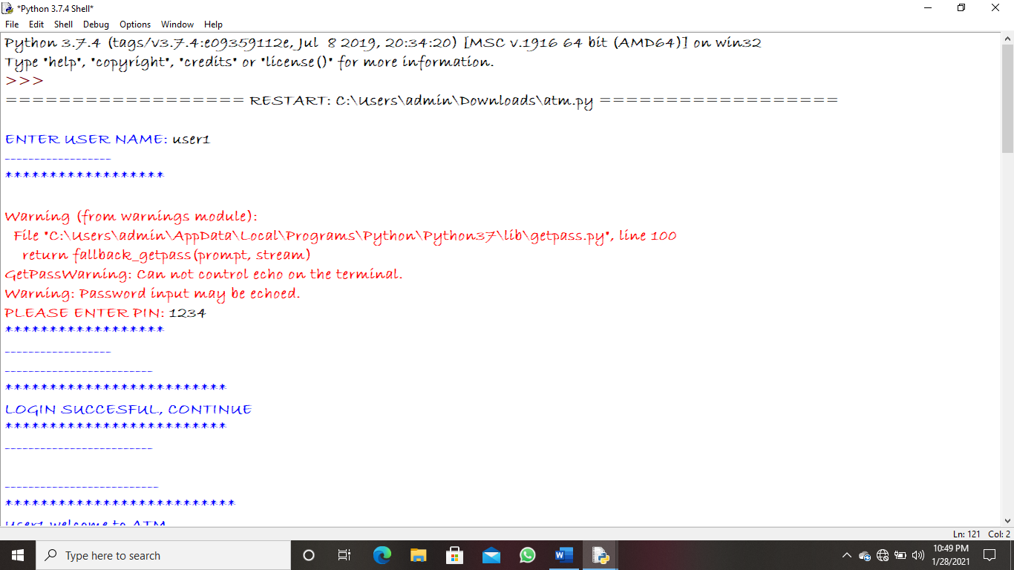

1. Login successful;

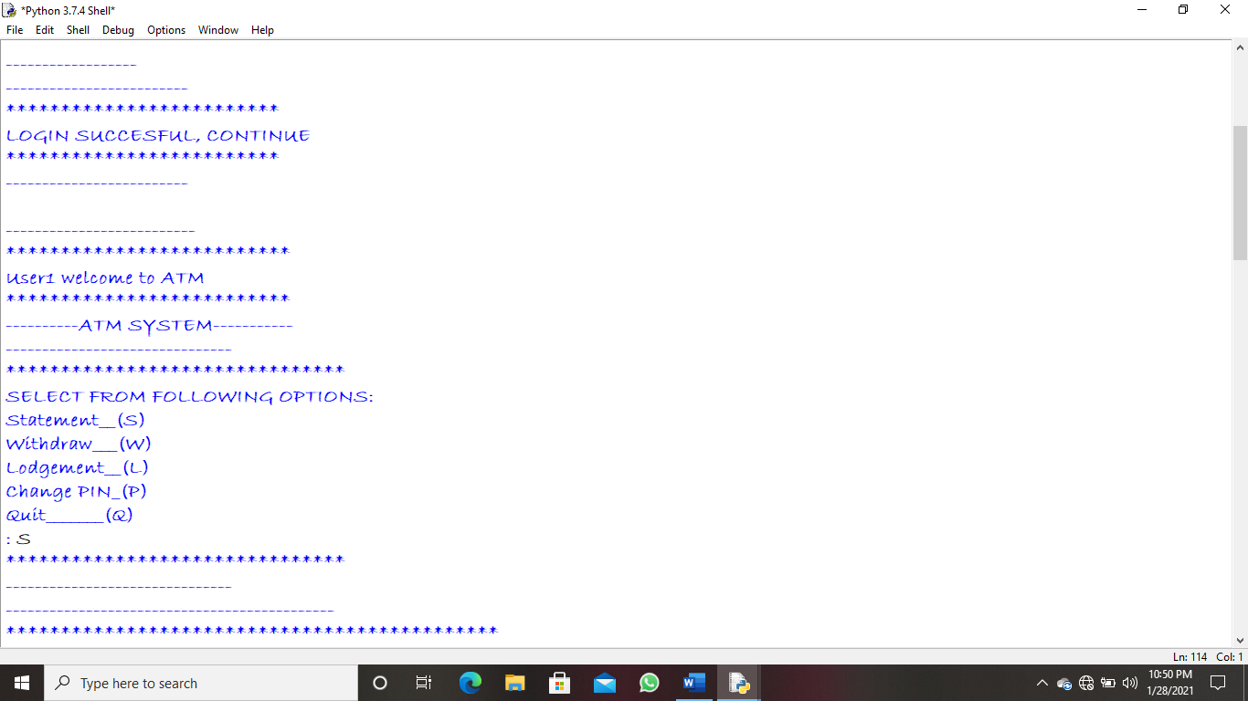

1. To view statement of user1/user2/user3;

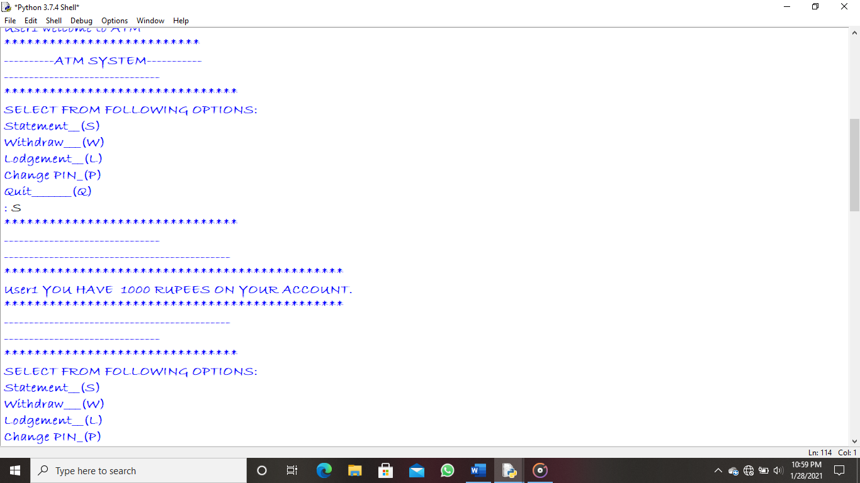

1. To change the pin;

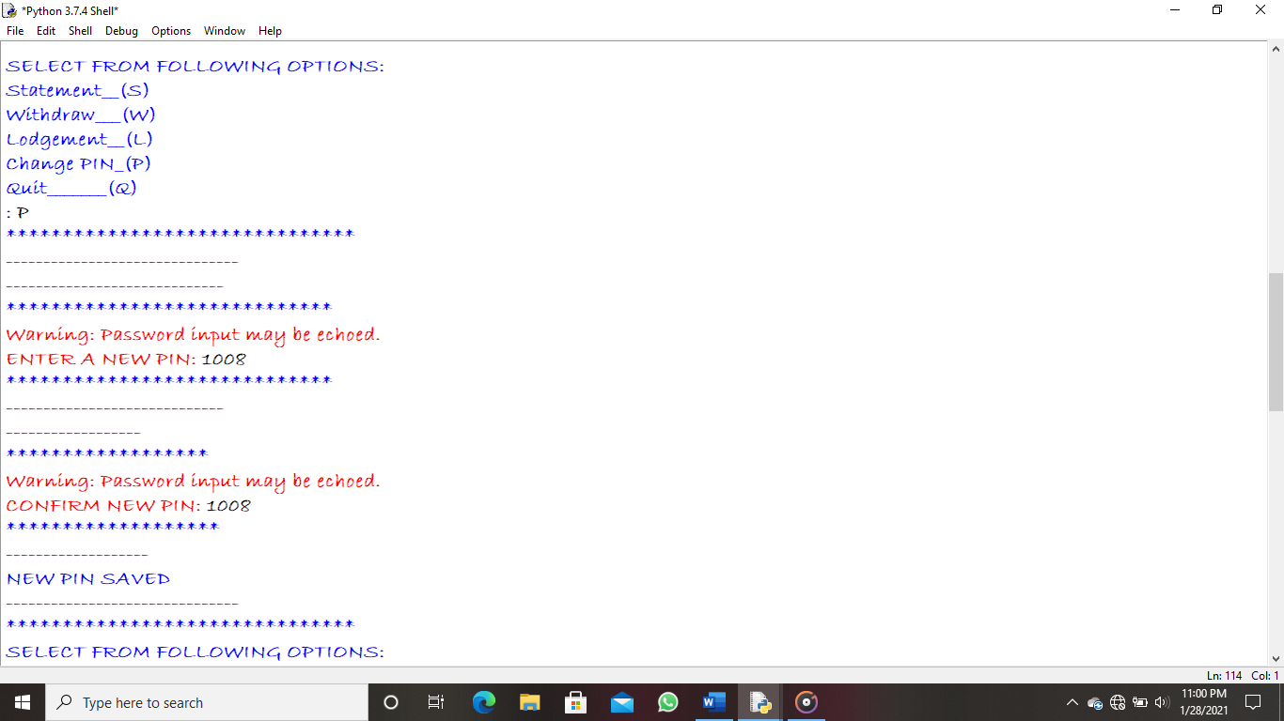

1. To deposit money in user1/user2/user3;

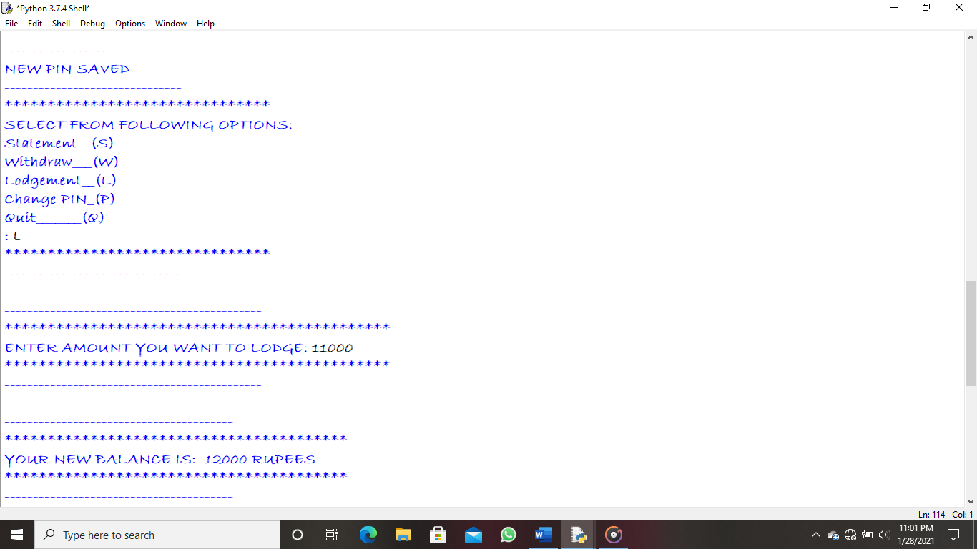

1. To withdraw money from user1/user2/user3;

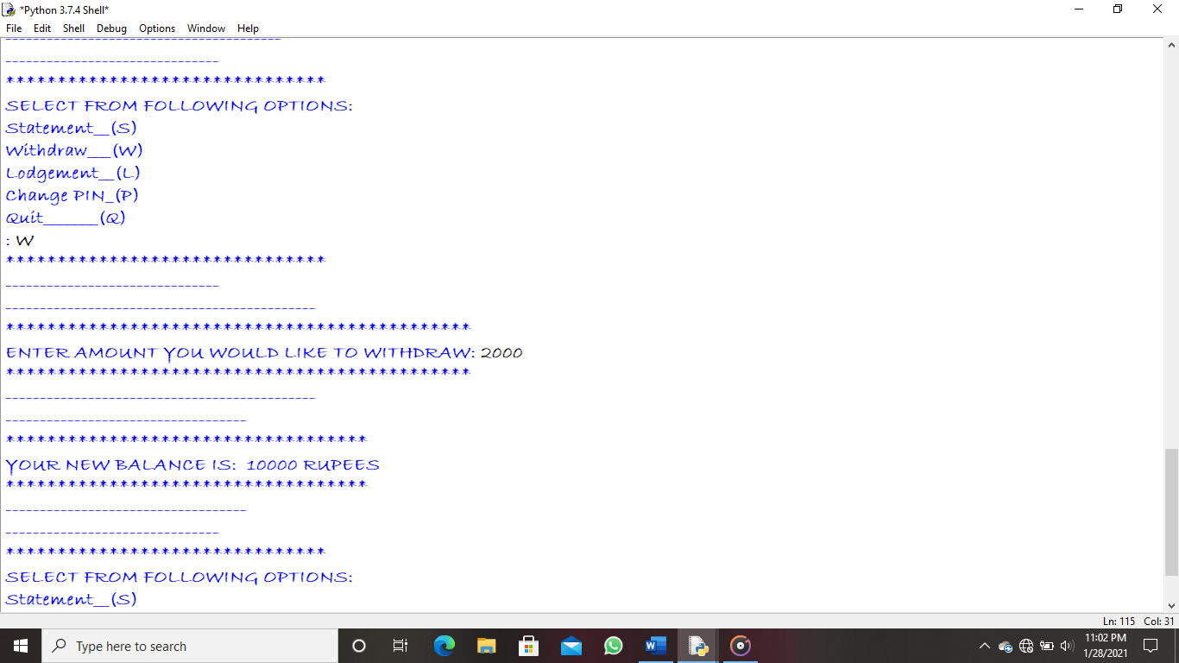

1. To quit program;

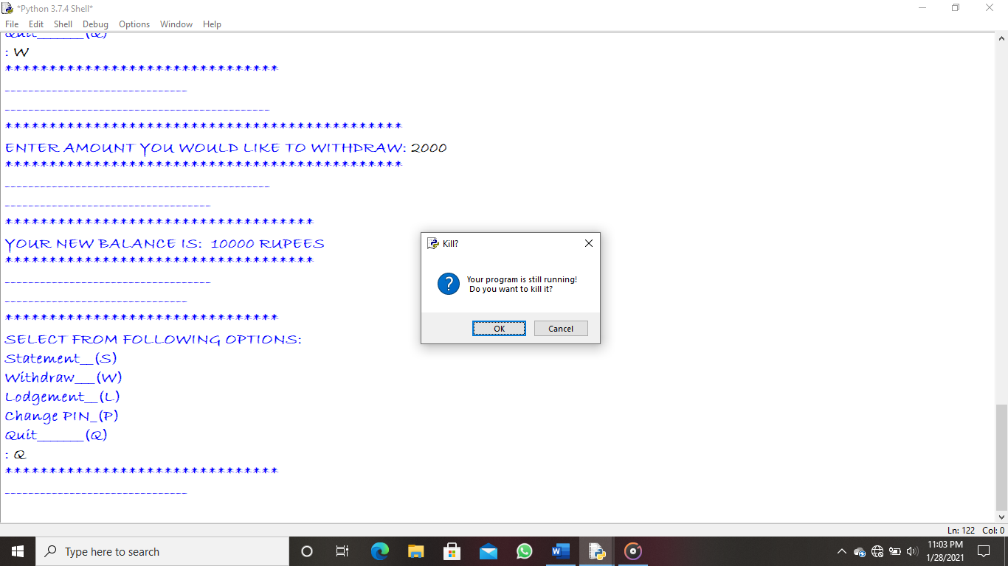

1. If invalid pin is entered 3 times, card will be blocked and no further transaction is taken place;

